**Tagesplan/ Alpen-Methode**

|  |  |  |  |  |
| --- | --- | --- | --- | --- |
| **Aufgabe** | **Dauer** | **Puffer** | **Prio** | **Nachkontrolle** |
|  |  |  |  |  |
|  |  |  |  |  |
|  |  |  |  |  |
|  |  |  |  |  |
|  |  |  |  |  |
|  |  |  |  |  |
|  |  |  |  |  |

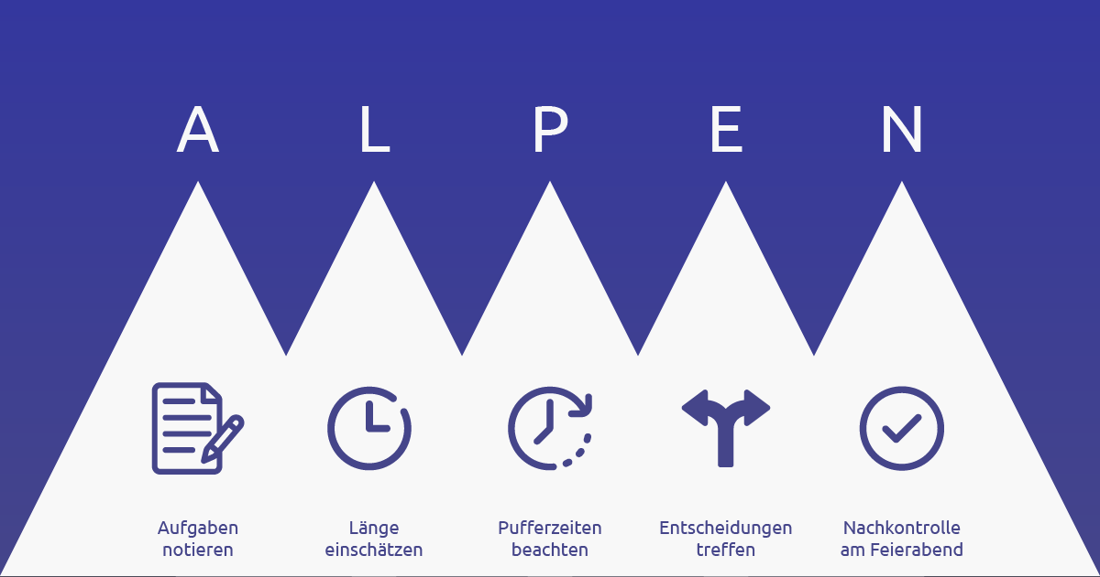

<https://www.fuer-gruender.de/blog/alpen-methode/>